Stasia Mculsky

Prosthetic Limbs- Giving Patients Their Bodies Back

*Abstract*

Currently there are 1.25 million amputees living in the United States, with 135,000 new amputations performed every year1. This has created a large need for prosthetics. Today there are varying levels of sophistication and complexity in prosthetics, correlating to price and availability. The simplest consist of a rubber or metal hand/arm that merely satisfies an aesthetic need for anatomical normalcy while other more complex options include brain interfaces to allow the patient to control the limb movement. Currently, a major endeavor in applied neuroscience relates to creating artificial limb prostheses that not only move according to the user’s intentions and relay sensations of touch, but that also feel as though they were the user’s own limbs2.In this paper, we will discuss the numerous methods being applied in the field of prosthetics in relation to brain interfaces and mechanical control, touch on the drawbacks of each method and speculate on how to improve and advance current technology. Unfortunately, while there has been significant progress in relation to the complexity of these prostheses, there are many cons, such as the impracticality in translation of some current designs to out-of-lab products. I will give some possible solutions to the accessibility and cost-effective dilemmas. The impact of this work is immeasurable; we are bringing quality of life up exponentially, function of limbs and self-sufficiency to a populous who so desperately desires a strong, fully functioning body.

*Introduction*

Globally there are more than 1 million annual limb amputations, one every 30 seconds, and it is projected that the amputee population will more than double by the year 2050 to 3.6 million4. Of this population, 70% of amputations are because of diseases, 22% due to trauma, 4% to congenital malformations and lastly 4% to tumors.1 There are rather large discrepancies on these numbers: as stated in the Advanced Amputee Solutions LLC statistics it claims the main causes are vascular disease (54%) including diabetes and peripheral arterial disease, trauma (45%), and cancer (less than 2%).4 Regardless, this is a large-scale medical problem to which a lot of money is being invested. Specifically, the US Department of Defense has invested 150 million dollars in prosthetics development coined as the “Revolutionizing Prosthetics” program.5 The issue at hand is multifold, a massive population has undergone a rather traumatic experience. It has left them psychologically damaged, in need of extensive physiotherapy, often in large amounts of debt and physically low functioning as they attempt to learn how to live their lives without a certain extremity. In addition to the copious amounts of logistical struggles people undergo after loss of limbs, there are also the issues at hand of accessibility, cost, and level of function of the prosthesis. In this paper, we will discuss the several types of prosthetics available currently. These range anywhere from no function aesthetic prosthetics to minimal function mechanical based prosthetics to prosthetics aimed at fully replacing the missing limb, both functionally and psychologically.

*Current Treatments*

On the most basic level of solutions available, there are passive devices with no functional purpose. Instead, they serve as aesthetic replacements of the amputated limb. These prosthetics typically consist of light weight, durable materials including a harness to keep it in place. A slight improvement includes the addition of myoelectric components that allow for limited function such as opening and closing the hand.1 Unfortunately, with these models, patients must endure extensive occupational therapy in order to master these prosthetics with little actual function resulting. More advanced prosthetics incorporate conductive biomaterials such as polymers and alloys allowing for flexible electronic based systems.1 These allow for more biocompatible prosthetics including sensors that are capable of sending electrical signals to dictate movement in the artificial limb.

Currently, the most clinically prevalent prosthetic is mechanically designed. Upper-limb prosthetics capture the remaining shoulder motion with a harness, and transfer this movement through a cable to operate the hand, wrist or elbow joints. Typically, only one joint can be operated at a time1. This is shown in **Figure 1**.1 For these prosthetics to function, the patient locks their joints they desire to keep static and this enables them to switch between different functions.1

Another current option is prosthetics that move based on EMG (electromyogram signals) from the muscles that are still present. Electrical signal recordings of the muscle contraction are taken from typically two separate muscles and in turn converted into signals that affect the patient’s motor neurons.1 Specific functions are determined by signal amplitude. In above elbow amputations, the bicep and tricep are utilized to manage wrist and hand motion. In contrast, for below elbow amputations, one wrist flexor and extensor muscles are strained to open and close the hand. When muscles contract, they generate changes in muscle membrane potentials. Although parts of the body are missing in amputations, these signals continue in the muscles of the remaining portion of the limb. In EMG controlled prosthetics, these signals are detected and converted into voltages measured by the EMG based prosthetic. This was predominantly done through the attachment of two external sensors to the skin of the limb.1 Specifically, in a device built by James, Roshan, and Cato T. Laurencin, these sensors were attached to the prosthetic via wires1. Lastly, a subset of myoelectric prosthetics utilize force sensors.1 These allow for the finger grasp pressure applied to be modeled linearly. Lastly, there is a possibility of the myoelectric component in addition to the mechanical prosthetic. This option comes into play predominately with very severe upper limb amputations.

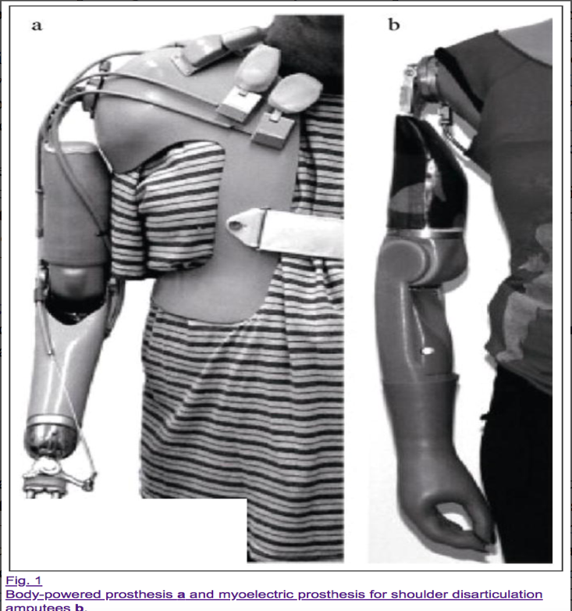

Figure 1: Body-powered prosthesis (a) and myoelectric prosthesis for shoulder amputees (b). Adapted from Regenerative Engineering and Bionic Limbs1.

*Current Research*

A major goal in prosthetic research is developing an artificial limb that moves in relation to patient’s intentions and provides the sensation that it is the patient’s actual arm or leg. In one study, investigators attempted to model a similar study to a study originally conducted in primates that proved sensory feedback from a prosthetic could be induced via electrodes in the somatosensory cortex.2 The goal of the new study was to determine whether electrical brain stimulation could be used to “bypass” the peripheral nervous system to elicit ownership of an artificial limb. In their experiment, they used direct cortical stimulation in two human subjects, who underwent invasive electrocorticographic (eCoG) monitoring in preparation for the epilepsy surgery, as shown in **Figure 2**.2 Their hypothesis was that it would be plausible to induce the feeling of one’s own hand by stimulation of the hand-sensory cortex in synchrony with touches delivered to an observed rubber hand without touching the real hidden hand2*.* Their results found that in both subjects, induced illusory ownership was prompted by the electrical brain stimulation of the hand-SI (somatosensory)cortex.2 In addition, they also found that stimulation of a non-hand region of the SI or doing it asynchronously does not result in the feeling of ownership of the prosthetic limb.2 This study supports the theory that the brain can integrate electrical cortical-somatosensory and visual cues to create a coherent sense of one’s limbs leading to crucial developments in prosthetics feeling like real limbs.

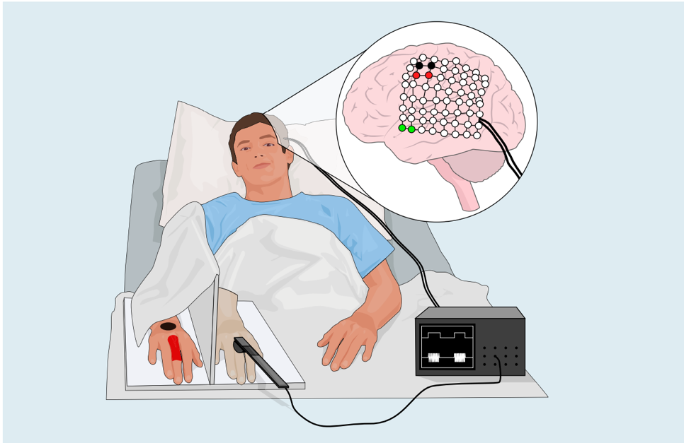

Figure 2: Experimental setup in which the real hand was hidden, rather the prosthetic was placed in sight. The prosthetic finger was stroked by a probe attached to a cortical stimulation device. This sent electrical signals to the primary SI cortex corresponding to the same finger (in red). The subject’s real hand was never touched. Adapted from Ownership of an Artificial Limb Induced by Electrical Brain Stimulation.2

EMG based prosthetics are also under continued development. Many issues were arising due to weak or non-existent signaling, along with lack of enough inputs.1 Scientists have been focusing on novel sensors with the ability to be placed directly into the muscle of the limb allowing for more control sites.1 Researchers hypothesize direct implantation allows for wireless transmission of intramuscular electrical signals to the prosthetic, enabling more natural movement.1 Richard Weir at the University of Colorado is at the forefront of this research known as the implantable myoelectric sensor system (IMES).5 This system enables far more control sites (i.e. more inputs) which then translates to more natural and intuitive movement along with simultaneous control of joints.5 His research is moving in the direction of implanting all 18 muscles in forearms. This would enable a wireless pathway for electrical signals to control not only hand movement but possible finger dexterity5. The first clinical trial was done at Walter Reed Medical Center on a man by the name of Staff Sergeant James.5 He was implanted with eight myoelectric sensors. These sensors allowed for the control of the prosthetic hand utilizing the IMES system5, notably for the first time in a human. This prosthetic allows for non-strenuous activity such as taking money out of his wallet. The general outline of this prosthetic design along with the implantable sensors is shown below in **Figure 3**.5

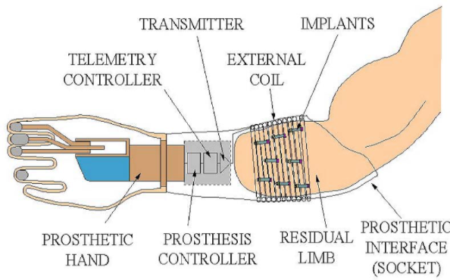

Figure 3: The main components of a prosthesis. Adapted from Implantable Sensors Improve Control for Prosthetic Limbs.5

Lastly, new treatments such as composite tissue transplants and targeted muscle re-innervation (TMR) are being researched and implemented. TMR is defined as the surgical rerouting of nerve signals to intact muscles which enables the mental control of prosthetics by just thinking about the movement.1 This is done by transferring the amputated nerves to the muscles left behind after amputation and allowing them to grow into the muscle. This supplies more control signals for the prosthetic. The nerve transfers typically have both sensory and motor axons which enables a multitude of simultaneous functions in the prosthetic. For example, after transferring the nerve into say the bicep, muscle contractions then produce an EMG signal which is then translated into device closure1. The patient then imagines carrying out a motion and the EMG signals from the desired muscle will translate into the movement performed by the prosthetic. Only around fifty hand transplants have been done since 20098, most of which were much less severe amputations, at the wrist or mid/distal forearm. Hand transplantation requires ample recovery time in order to allow osteointegration, tendon healing and muscle re-innervation prior to active rehabilitation1. Graft survival has had an extremely high success rate (95.6%).8

*Comparison and Discussion*

There are a multitude of cons in regards to the widely accepted/most common prosthetic solutions. For example, in relation to the body powered prosthetics, the harness involved greatly hinders the patient’s range of motion. In addition, body powered prosthetics don’t really enable any sort of strenuous activities. Long term studies have shown that body-powered prosthesis has been correlated to debilitating shoulder issues, nerve entrapment or pinching and anterior muscle imbalances1. Lastly, patients often struggle the most with body powered prosthetics because the aesthetic is furthest from a real limb. They also do not allow for any mental integration often leading to patients feeling as though the prosthetics is not truly their limb leading to depression and lowered compliance.

Some downfalls for EMG based prosthetics are in above elbow amputations. For example, transhumeral amputees rely on shoulder muscles to navigate the hand/wrist/elbow in the prosthetic. In this type of amputation, there are very few muscles capable of powering the prosthetic and no humerus to place the terminal device.1 In addition, EMG based prosthetics experience issues due to poor, unreliable signals. Skin’s ever-changing conditions lead to issues when sweat and loss of sensor adhesion occurs.1 This results in often unreliable, if any, signals and in turn reduces function and control of the prosthetics. When patients feel as though their prosthetic isn’t working to the desired function, rejection often occurs. Additionally, there are often not enough sensory inputs to control the number of actions desired from the prosthetic.

In proximal amputations, patients struggle due to severe loss of input sources leading to lack of ability to produce isolated EMG signals and repeatable contractions. A step in advancing these EMG sensors into implantable ones is solving many of the downfalls of this strategy. For example, implanted EMG sensors enable a wireless transmission of signal. In addition, the signals are far more specific and consistent since factors related to adhesion to the skin, such as sweat, are eliminated. The possibility for all 18 muscle implants would far surpass the current two sensor prosthetics1 which only enable open and close functions.

In contrast to the options mentioned above, targeted muscle re-innervation and tissue transplantation have far more potential to allow for the most functionality depending on several variables such as risk of procedure, severity of amputation and costs. Transplantation has the potential to enable greater human limb function and appearance. This feeling of normality that comes with a human limb appearance has massive psychological benefits. While we discussed the positives of transplantation, there are many negatives. For example, the actual surgery in which the transplantation occurs is very difficult. It involves numerous surgical teams. On top of this, for the rest of his/her life, the patient will have to take multi-drug immunosuppressants1. Not only is this an issue for compliance of the patient, (i.e., the patient adhering to the medical protocol of how often the medicine must be consumed), but also immunosuppressants often come with serious life-threatening side effects. Yet another downside of this option is the lack of ability to translate into market. For example, due to the excessive surgical risk and heavy monetary cost, the widespread application of limb transplantation is not plausible, particularly in third world countries. TMR outweighs other options on the grounds that it allows for more than one motion at a time. In addition, TMR often allows for sensory nerve regeneration which enables phantom limb sensations. This feeling allows for increased utility of the prosthetic but also allows the patient to feel sensations like pain or heat as if it were their old limb feeling it.1

Lastly, the rubber hand study2 suggested a major advancement on the other methods currently used in prosthetics. Current prosthetics typically rely on peripheral somatosensory stimulation, including tactile stimulation of the amputated area or a re-innervated patch of skin. With this research, there is the possibility of completely bypassing the peripheral nervous system utilizing direct cortical stimulation2. This allows patients who don’t have afferent input from the damaged limb to feel as though their prosthetic belongs to them.

*Conclusion and Future Work*

As you can see, the world of prosthetics is ever evolving and extremely necessary for such a large market. The level of complexity and ability of available prosthetics greatly relies on cost and translation to the clinic. There are many ways prosthetics can be improved to better serve patients. For example, there are several commercially available prosthetics that are able to give minimal sensory feedback, including temperature. However, including more sensors in the muscles to give a larger number of feedback signals will increase the functions capable when utilizing the prosthetic.1 In addition, improvements to IMES can be implemented by increasing the data transfer rate and modifying the system so it uses less power.5 Logistically, there is obvious room for improvement in relation to the actual technology of the prosthetics and there are also ample social issues that come with amputation solutions. One of the most complex, life like hands has been developed by Johns Hopkins and sells for half a million dollars.3 In reality, no one can afford this high-end product. One of the greatest issues with the current development of prosthetics is the cost and inability to translate to a wide market. Not only do many in lab prosthetics have far too much complexity to increase scale of production, they also aren’t able to be replicated in most labs around the world. Hand transplants are even more challenging to replicate around the world. Hand transplants require several advanced teams of surgeons, which is not realistic everywhere and requires significant clinical expertise.

In addition to the monetary gap apparent in prosthetics, there is also the social aspect to take into consideration. For example, in certain parts of the world, for example the Middle East, it is not socially acceptable to have visible prosthetics. This social stigmatization leads to patients neglecting to wear their prosthetic and suffering from the somewhat debilitating lack of a functioning limb. On a less severe social note, there is also stigmatization that occurs worldwide when someone does not look “normal.” When patients feel abnormal, adherence to the clinical regimen drops exponentially. In addition, psychologically, there are many negative side effects of losing a limb and having a replacement that feels less than human. The benefit of the hand transplant is the psychological component. Hand transplants are warm to the touch, unlike the hard cold metal of some prosthesis. In addition, it’s aesthetically pleasing and leaves the user feeling more whole again. The entire purpose of prosthetics is regaining functionality and feeling normal again. This needs to be the new focus of prosthetics, rather than trying to further the technology while disregarding the psychological implications of the device.

A great misconception about the field of prosthetics is that we have not engineered a prosthetic that is very capable of replacing a hand. Rather, the science is there, the technology is discovered, but we have not managed to make this technology available to more than the fraction of a percent of patients, targeting only the small subset of wealthy amputees. Most of the scientific research has been accomplished, yet we still have not managed to make widely accessible and cost effective prosthetic that resembles the amputated limb. I suggest a universal base model that includes implantable sensors, requiring a very minimal, non-invasive surgery. These implanted sensors remove the variability in signals that skin sensors typically produce to include more stable, accurate signals allowing for more complex motion.5 This minor surgery is possible through small incisions that require a few stiches, placing the sensors in the muscle. This minimalistic procedure would make it more manageable for surgeons everywhere to perform instead of the highly complex, rather un-replicable procedure of hand transplants. By making this surgery more attainable, a greater population, in desperate need of prosthetics, will be served. In addition, I think we must dial back the complexity of several of the models such as the JHU hand prosthesis. While the abilities of these more sophisticated models are incredible, in order to reach broader markets, the design must be complex enough to give back moderate function without excessive features. For example, the JHU hand prosthetic has the ability to lift up to 45 pounds.3 This is somewhat unnecessary as it is beyond basic function and, the more extraneously complex the model is, the harder it is to make a universal, accessible design. Lastly, I think we must develop a synthetic skin that covers the metal prosthesis that allows it to look somewhat more human like. In addition, offering the prosthetics in a multitude of skin colors would create an inclusive, exciting option for amputees. Creating a prosthesis that allows the patient to feel somewhat normal again increases quality of life significantly, which is the main goal of prosthetics. We must shift the focus from making the most complex, superhero like hand prosthesis to a cost efficient, widely accessible, human resembling option. We can achieve this through several methods.

In conclusion, I propose that groups such as the American Orthotic and Prosthetic Association, or another large prosthetic oriented body, could conduct international lectures on prosthetic making and surgical implantation of sensors. By increasing the education levels worldwide, we can increase the number of markets where treatment is available. In addition, we could place the prototyping specifications of a solid base model with sufficient function online so that anyone with internet access has the exact details of the design and can hopefully replicate it and surgeons could learn how to perform the surgery necessary to implant the sensors. Lastly, on the topic of aesthetics, in order to make the prosthetics more human like, we could bring in artists, that focus on realism, to paint the prosthetic with freckles, scars and varying skin shades. In summation, they are several minor scientific specifications that could be improved such as addition of more sensors, better battery life, wireless sensor transmission of signals. But more importantly, we need to focus of access and aesthetic user needs. This is far more crucial as if a user is unhappy with how their prosthetic looks, adherence drops exponentially and if a user is not utilizing their prosthetic, the entire design is pointless. In addition, we need to make the prosthetics market accessible to all people, including low income, third world country inhabitants. The field of prosthetics is an incredibly important, large market. We must work to make the population of amputees feel empowered, fully functioning and normal once again.

Works Cited

1. James, Roshan, and Cato T. Laurencin. “Regenerative Engineering and Bionic Limbs.” *Rare Metals*, vol. 34, no. 3, 2015, pp. 143–155., doi:10.1007/s12598-015-0446-0.
2. Collins, Kelly L., et al. “Ownership of an Artificial Limb Induced by Electrical Brain Stimulation.” *Proceedings of the National Academy of Sciences*, vol. 114, no. 1, 2016, pp. 166–171., doi:10.1073/pnas.1616305114.
3. Times, The New York. “Prosthetic Limbs, Controlled by Thought.” *The New York Times*, The New York Times, 20 May 2015, [www.nytimes.com/2015/05/21/technology/a-bionic-approach-to-prosthetics-controlled-by-thought.html](http://www.nytimes.com/2015/05/21/technology/a-bionic-approach-to-prosthetics-controlled-by-thought.html).
4. “Innovative Solutions for a New Age of Amputees | AdvancedAmputees.com.” *Innovative Solutions for a New Age of Amputees | AdvancedAmputees.com*, [www.advancedamputees.com/](http://www.advancedamputees.com/).
5. “Implantable Sensors Improve Control for Prosthetic Limbs.” *National Institute of Biomedical Imaging and Bioengineering*, U.S. Department of Health and Human Services, 3 Mar. 2017, [www.nibib.nih.gov/news-events/newsroom/implantable-sensors-improve-control-prosthetic-limbs](http://www.nibib.nih.gov/news-events/newsroom/implantable-sensors-improve-control-prosthetic-limbs).
6. Borton, D., et al. “Personalized Neuroprosthetics.” *Science Translational Medicine*, vol. 5, no. 210, 2013, doi:10.1126/scitranslmed.3005968.
7. Hotson, Guy, et al. “Individual Finger Control of a Modular Prosthetic Limb Using High-Density Electrocorticography in a Human Subject.” *Journal of Neural Engineering*, vol. 13, no. 2, 2016, p. 026017., doi:10.1088/1741-2560/13/2/026017.
8. Salminger, S., et al. *Current Surgery Reports*, Springer US, 2016, www.ncbi.nlm.nih.gov/pmc/articles/PMC4729794/.

